**BI applications and design**

**BI applications and design**

The project team needs to develop BI content specifications in order to design and document the BI applications that they are going to build. The BI project often uses an iterative and incremental methodology that includes a mix of waterfall and agile for specific portions of the project.

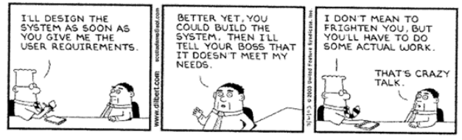

BI solution types include:

* Dashboards
* Ad hoc analytics/ OLAP
* Balanced scorecards
* Performance management
* GIS and other visualisation
* Predictive analytics/ data mining
* Reporting
* Alerts and exception
* Analytical CRM

BI requirements examples are: Business, information, functional, usage reequipments. What is the problem? What do we need to answer the problem? What data do we need? How do we need to use the information that results from the data to tackle the problem? What type of layout do I want? Other non-fictional requirements?

**Lifecycle of BI specification process**

There is no need to struggle to select your BI solution. You need to be clear on your requirements and to familiarise yourself with the different solutions.

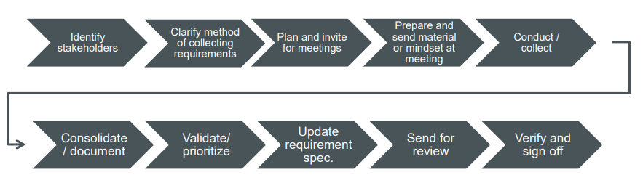

Sherman, R. (2015). Business intelligence guidebook : from data integration to analytics. Elsevier. Chapter 13

**Further reading / extension activity**

<https://youtu.be/ZMB_6OeCEP8>